# Excess Portfolio Returns Analysis

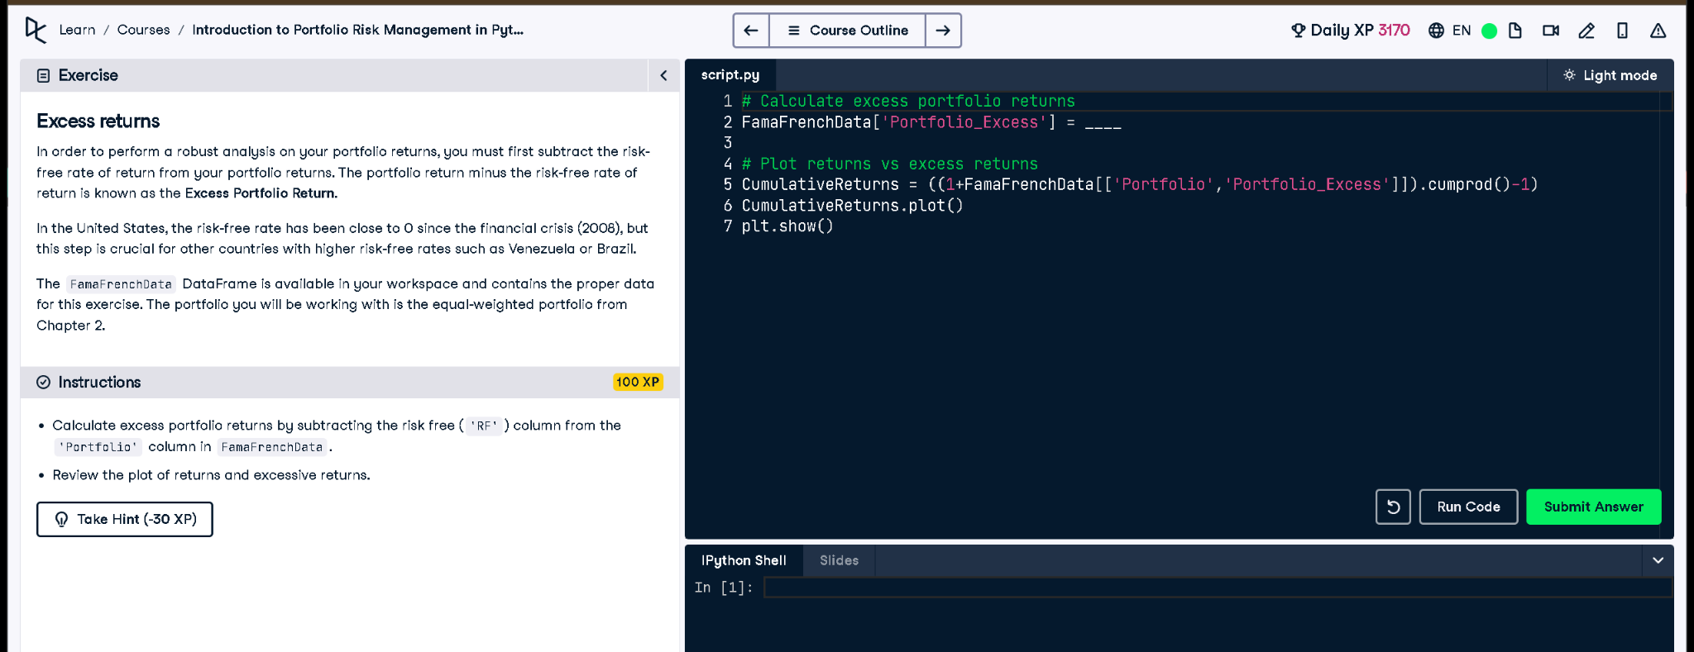

Figure: Exercise interface from DataCamp

## Python Code

# Calculate excess portfolio returns  
FamaFrenchData['Portfolio_Excess'] = FamaFrenchData['Portfolio'] - FamaFrenchData['RF']  
  
# Plot returns vs excess returns  
CumulativeReturns = ((1 + FamaFrenchData[['Portfolio', 'Portfolio_Excess']]).cumprod() - 1)  
CumulativeReturns.plot()  
plt.show()

## Explanation

To measure how well a portfolio performs beyond the risk-free return, we calculate excess returns. This is done by subtracting the risk-free rate (RF) from the actual portfolio return. Then we plot both total and excess cumulative returns to visualize the added value over time.